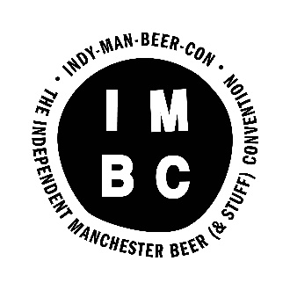

VOLUNTEER INFORMATION

In return for volunteering, we offer:
1x free session
15x beer tokens
1x meal
1x IMBC T-shirt
1x ruddy good time!

IMPORTANT DATES

Volunteer Briefing (location TBC): evening of Sunday 25th or Monday 26th September (you pick one date depending on your availability).
Day session and evening session volunteers required on:
Thursday 6th October – Sunday 9th October
Volunteers join us for at least x1 session on 1 of these days.
Volunteers also need in set up and take down days during the daytime:
Tuesday 4th October, Wednesday 5th October & Monday 10th October

MAIN ROLE

Session Volunteers

Session Volunteers are the biggest group of volunteers.
We need volunteers to take various positions during each session. This includes pouring beer, welcoming attendees, providing information front of house, selling tokens and clearing the space.

If you have good beer knowledge, please flag this up for the beer pouring position.

All volunteers need to be friendly, well-motivated and be able to remain calm in a fast paced, busy environment.

We ask that all volunteers join us for at least x1 session over the festival period.

OTHER ROLES

Event Assistant

We are looking for x1 volunteer at each session to assist the Events Supervisor. They will need to be friendly, informative and pro-active to help run a very bust events schedule at each session.

This is a great one for those with some events experience but who are looking to gain more in a festival environment.

Set Up/Take Down

In addition to volunteering at the festival itself, we have x2 set up days (4th – 5th October) and x1 take down day (10th October) which we require volunteers to assist at. The roles are incredibly varied on these days and we will need help with everything from setting up bars, putting beer in the right places, setting up furniture, and arranging glasses and tokens.

A FEW T’S AND C’S

All IMBC volunteers are highly valued as part of the festival team and will receive a great experience and support.

We ask that all volunteer sign a simple Volunteer Agreement prior to the festival, which details what you can expect from us, and what we would like from you. This will be provided in the Briefing Session.

For now, a few things you need to know:

★ All volunteers must be 18 years or over on their first day of volunteering.

★ All volunteers must be available for at least volunteer briefing on Sunday 25th or Monday 26th September and for x1 session at the event. Please let us know of any additional availability on your application form.

★ We don’t take deposits and instead trust our volunteers to fulfil their commitment. We ask that once all volunteers are committed to their role that they see it through. We rely on you!! You’re important!!

★ Drinking whilst on shift is not permitted (beyond shot glass tasting of the beers if you are pouring). Any volunteer found to be drinking on shift will be asked to leave the event. You are more than welcome to drink as much as you like during your free session / when attending the event at other times.

★ Free sessions are limited in capacity and available on a first come, first served basis. You are not guaranteed to get your first choice of free session.

HOW TO APPLY

If you would like to apply to volunteer please complete the online Volunteer Application Form, linked on our website.

The submission deadline is ​5pm on Friday 16th September ​​however we advise that you apply as early as you possibly can as places are limited.

Applications will be reviewed and places filled on a rolling basis before the deadline. We receive a high volume of applications, so please bob your application in quick sharp!

For any questions please don’t hesitate to contact us on volunteers@indymanbeercon.com

We welcome applications from all ages, abilities and sections of the community.

