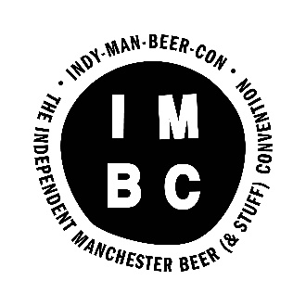

VOLUNTEER INFOR

INDY MAN BEER CON 2017 - VOLUNTEER INFORMATION

In return for volunteering, we offer:
X1 free session
X15 beer tokens
X1 IMBC T-shirt
A ruddy good time!

IMPORTANT DATES

Deadline for volunteer applications: Friday 8th September, 5pm
Volunteer Briefings – You need to attend 1 of these sessions Sunday 17th September at 5pm or Monday 18th September at 6.30pm, both taking place at Port Street Beer House, Northern Quarter..

Day session and evening session volunteers required on:
Thursday 28th September – Sunday 1st October
Volunteers join us for at least x1 session on 1 of these days.

You will be able to indicate which sessions / times you are available on your Application Form. Please note, that there are a limited number of volunteer positions available at each session. We fill these on a first come, first served basis.

VOLUNTEER ROLES

Session Volunteers

All of our volunteers during the event join us as Session Volunteers, taking on various positions during each session. This includes pouring beer, welcoming attendees, providing information front of house, selling tokens and clearing the space.

If you have good beer knowledge and bar experience, please flag this up for the beer pouring position.

All volunteers need to be friendly, well-motivated and be able to remain calm in a fast paced, busy environment.

Set Up/Take Down

In addition to volunteering at the festival itself, we have x3 set up days (Tuesday 26th – Thursday 28TH September) and x1 take down day (Monday 2nd October) which we require volunteers to assist at. The roles are incredibly varied on these days and we will need help with everything from setting up bars, putting beer in the right places, setting up furniture, and arranging glasses and tokens.

We don’t accept volunteers who will join us for only set-up and take-down, we ask that you also volunteer at the festival itself.

A FEW T’S AND C’S

All IMBC volunteers are highly valued as part of the festival team and will receive a great experience and support.

We ask that all volunteer sign a simple Volunteer Agreement prior to the festival, which details what you can expect from us, and what we would like from you. This will be provided in the Briefing Session.

For now, a few things you need to know:

★ All volunteers must be 18 years or over on their first day of volunteering.

★ All volunteers must be available for at least briefing on Sunday 17th or Monday 18th September and for x1 session at the event itself. Please let us know of any additional availability on your application form.

★ We don’t take deposits and instead trust our volunteers to fulfil their commitment. We ask that once all volunteers are committed to their role that they see it through. We rely on you!! You’re important!!

★ Drinking whilst on shift is not permitted (beyond shot glass tasting of the beers if you are pouring). Any volunteer found to be drinking on shift will be asked to leave the event. You are more than welcome to drink as much as you like during your free session / when attending the event at other times.

★ Free sessions are allocated on a first come first served basis also and are limited at each session.

HOW TO APPLY

If you would like to apply to volunteer please complete the online Volunteer Application Form here https://goo.gl/forms/lvtTCT5VjhQtkCch2

The submission deadline is ​5pm on Friday 8th September ​​however we advise that you apply as early as you possibly can as places are limited.

Applications will be reviewed and places filled on a rolling basis before the deadline. We receive a high volume of applications, so please bob your application in quick sharp!

For any questions please don’t hesitate to contact us on volunteers@indymanbeercon.co.uk

We welcome applications from all ages, abilities and sections of the community.

